#
# 20200327
#
# https://jira.tcsbank.ru/browse/IN-40
#

#
# Was detected follow message
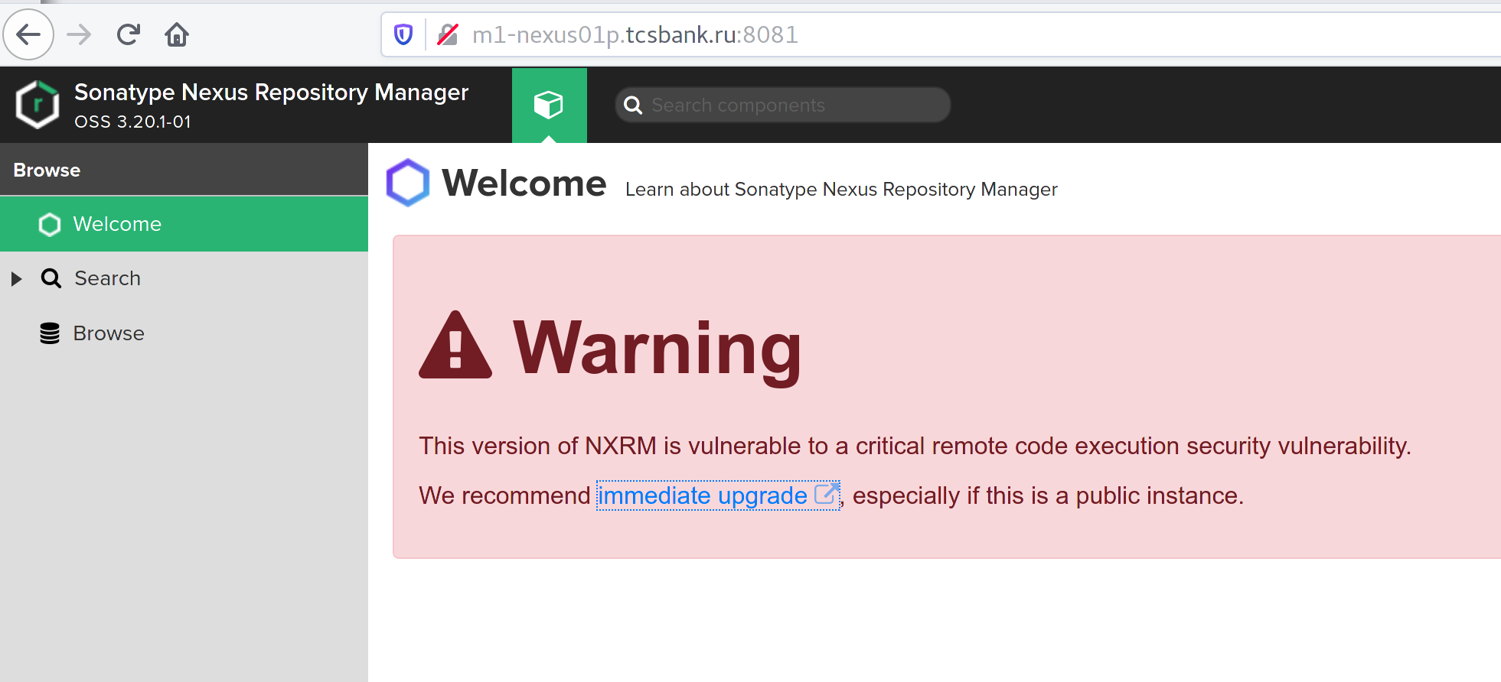

#
# Was downloaded latest version. It awailable by link on this warning.

# Update was made by following this instructions.
# https://support.sonatype.com/hc/en-us/articles/115000350007?_ga=2.263777993.490287073.1585223817-1088252597.1585223817
#

................................................................................

[s.belogrud@TCS4357]# scp /drives/e/data/distributives/nexus/nexus-3.21.2-03-unix.tar.gz bsv@m1-nexus01p:/tmp/
nexus-3.21.2-03-unix.tar.gz 100% 134MB 20.8MB/s 00:06
[s.belogrud@TCS4357]#

................................................................................

[root@m1-nexus01p ~]# mkdir -p ~/work/20200327-1603
[root@m1-nexus01p ~]# cp /tmp/nexus-3.21.2-03-unix.tar.gz ~/work/20200327-1603/
[root@m1-nexus01p ~]# cd ~/work/20200327-1603/

[root@m1-nexus01p 20200327-1603]# tar -xvzf ~/work/20200327-1603/nexus-3.21.2-03-unix.tar.gz -C /opt/nexus/

[root@m1-nexus01p 20200327-1603]# ls -Alh /opt/nexus/
total 0
drwxr-xr-x. 9 nexus nexus 163 Jan 31 18:10 nexus-3.20.1-01
drwxr-xr-x 9 root root 163 Mar 27 16:06 nexus-3.21.2-03
drwxrwxr-x. 15 nexus nexus 248 Feb 4 19:38 nexus-data
drwxr-xr-x. 3 nexus nexus 20 Jan 31 18:10 sonatype-work
[root@m1-nexus01p 20200327-1603]#

................................................................................

[root@m1-nexus01p 20200327-1603]# diff -Nuar /opt/nexus/nexus-3.20.1-01/bin/nexus.vmoptions /opt/nexus/nexus-3.21.2-03/bin/nexus.vmoptions
--- /opt/nexus/nexus-3.20.1-01/bin/nexus.vmoptions 2020-01-31 18:41:33.507155077 +0300
+++ /opt/nexus/nexus-3.21.2-03/bin/nexus.vmoptions 2020-03-19 00:48:27.000000000 +0300
@@ -11,7 +11,7 @@
-Dkaraf.base=.
-Dkaraf.etc=etc/karaf
-Djava.util.logging.config.file=etc/karaf/java.util.logging.properties
--Dkaraf.data=/opt/nexus/nexus-data
+-Dkaraf.data=../sonatype-work/nexus3
-Dkaraf.log=../sonatype-work/nexus3/log
-Djava.io.tmpdir=../sonatype-work/nexus3/tmp
-Dkaraf.startLocalConsole=false
[root@m1-nexus01p 20200327-1603]#

[root@m1-nexus01p 20200327-1603]# vim /opt/nexus/nexus-3.21.2-03/bin/nexus.vmoptions -c ":/-Dkaraf.data="
[root@m1-nexus01p 20200327-1603]# grep -e ":/-Dkaraf.data=" /opt/nexus/nexus-3.21.2-03/bin/nexus.vmoptions
[root@m1-nexus01p 20200327-1603]# grep -e "-Dkaraf.data=" /opt/nexus/nexus-3.21.2-03/bin/nexus.vmoptions
-Dkaraf.data=/opt/nexus/nexus-data
[root@m1-nexus01p 20200327-1603]#

[root@m1-nexus01p 20200327-1603]# cat /etc/systemd/system/nexus.service
[Unit]
Description=nexus service
After=network.target

[Service]
Type=forking
LimitNOFILE=65536
ExecStart=/opt/nexus/nexus-3.20.1-01/bin/nexus start
ExecStop=/opt/nexus/nexus-3.20.1-01/bin/nexus stop
User=nexus
Restart=on-abort

[Install]
WantedBy=multi-user.target
[root@m1-nexus01p 20200327-1603]#

[root@m1-nexus01p 20200327-1603]# systemctl status nexus
в—Џ nexus.service - nexus service
Loaded: loaded (/etc/systemd/system/nexus.service; enabled; vendor preset: disabled)
Active: active (running) since Tue 2020-02-04 19:38:37 MSK; 1 months 21 days ago
Main PID: 6100 (java)
CGroup: /system.slice/nexus.service
в””в”Ђ6100 /usr/lib/jvm/java-1.8.0-openjdk-1.8.0.242.b08-0.el7_7.x86_64/jre/bin/java -server -Dinstall4j.jvmDir=/usr/lib/jvm/java-1.8.0-openjdk-1.8.0.242.b08-0.el7_7.x86_64/jre -Dexe4j.m...

Warning: Journal has been rotated since unit was started. Log output is incomplete or unavailable.
[root@m1-nexus01p 20200327-1603]#

[root@m1-nexus01p 20200327-1603]# systemctl stop nexus
[root@m1-nexus01p 20200327-1603]# systemctl status nexus
в—Џ nexus.service - nexus service
Loaded: loaded (/etc/systemd/system/nexus.service; enabled; vendor preset: disabled)
Active: inactive (dead) since Fri 2020-03-27 16:19:07 MSK; 32s ago
Process: 30925 ExecStop=/opt/nexus/nexus-3.20.1-01/bin/nexus stop (code=exited, status=0/SUCCESS)
Main PID: 6100 (code=exited, status=0/SUCCESS)

Mar 27 16:19:03 m1-nexus01p.tcsbank.ru systemd[1]: Stopping nexus service...
Mar 27 16:19:03 m1-nexus01p.tcsbank.ru nexus[30925]: Shutting down nexus
Mar 27 16:19:07 m1-nexus01p.tcsbank.ru nexus[30925]: Stopped.
Mar 27 16:19:07 m1-nexus01p.tcsbank.ru systemd[1]: Stopped nexus service.
Warning: Journal has been rotated since unit was started. Log output is incomplete or unavailable.
[root@m1-nexus01p 20200327-1603]# vim /etc/systemd/system/nexus.service
[root@m1-nexus01p 20200327-1603]# cat /etc/systemd/system/nexus.service
[Unit]
Description=nexus service
After=network.target

[Service]
Type=forking
LimitNOFILE=65536
ExecStart=/opt/nexus/nexus-3.21.2-03/bin/nexus start
ExecStop=/opt/nexus/nexus-3.21.2-03/bin/nexus stop
User=nexus
Restart=on-abort

[Install]
WantedBy=multi-user.target
[root@m1-nexus01p 20200327-1603]# systemctl daemon-reload
[root@m1-nexus01p 20200327-1603]# systemctl start nexus
[root@m1-nexus01p 20200327-1603]# systemctl status nexus
в—Џ nexus.service - nexus service
Loaded: loaded (/etc/systemd/system/nexus.service; enabled; vendor preset: disabled)
Active: active (running) since Fri 2020-03-27 16:20:58 MSK; 11s ago
Process: 31245 ExecStart=/opt/nexus/nexus-3.21.2-03/bin/nexus start (code=exited, status=0/SUCCESS)
Main PID: 31419 (java)
CGroup: /system.slice/nexus.service
в””в”Ђ31419 /usr/lib/jvm/java-1.8.0-openjdk-1.8.0.242.b08-0.el7_7.x86_64/jre/bin/java -server -Dinstall4j.jvmDir=/usr/lib/jvm/java-1.8.0-openjdk-1.8.0.242.b08-0.el7_7.x86_64/jre -Dexe4j....

Mar 27 16:20:57 m1-nexus01p.tcsbank.ru systemd[1]: Starting nexus service...
Mar 27 16:20:58 m1-nexus01p.tcsbank.ru systemd[1]: Started nexus service.
[root@m1-nexus01p 20200327-1603]#

#
# After ~3 minutes web page starts open: http://m1-nexus01p.tcsbank.ru:8081/
#
[root@m1-nexus01p 20210405-1823]# netstat -nlptu | grep -e 8081
tcp 0 0 0.0.0.0:8081 0.0.0.0:* LISTEN 18263/java
[root@m1-nexus01p 20210405-1823]#

# The first login after update.
# See current installed version: 3.21.2-03
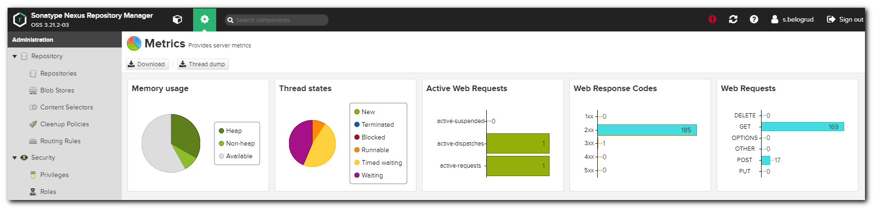

#
# 20200703
# Update Nexus from 3.21 to 3.24.
#

[s.belogrud@TCS4357]# scp /drives/c/Users/s.belogrud/Downloads/nexus-3.24.0-02-unix.tar.gz bsv@m1-nexus01p:/tmp/
nexus-3.24.0-02-unix.tar.gz 100% 150MB 18.7MB/s 00:08
[s.belogrud@TCS4357]#

[root@m1-nexus01p ~]# mkdir work/20200703-1141
[root@m1-nexus01p ~]# mv /tmp/nexus-3.24.0-02-unix.tar.gz work/20200703-1141/
[root@m1-nexus01p ~]# cd work/20200703-1141/
[root@m1-nexus01p 20200703-1141]#

[root@m1-nexus01p 20200703-1141]# tar -xvzf nexus-3.24.0-02-unix.tar.gz -C /opt/nexus/

[root@m1-nexus01p 20200703-1141]# ls -Alh /opt/nexus/
total 0
drwxr-xr-x. 9 nexus nexus 163 Jan 31 18:10 nexus-3.20.1-01
drwxr-xr-x 9 root root 163 Mar 27 16:06 nexus-3.21.2-03
drwxr-xr-x 9 root root 163 Jul 3 11:43 nexus-3.24.0-02
drwxrwxr-x. 16 nexus nexus 264 May 12 10:21 nexus-data
drwxr-xr-x. 3 nexus nexus 20 Jan 31 18:10 sonatype-work
[root@m1-nexus01p 20200703-1141]#

[root@m1-nexus01p 20200703-1141]# diff -Nuar /opt/nexus/nexus-3.21.2-03/bin/nexus.vmoptions /opt/nexus/nexus-3.24.0-02/bin/nexus.vmoptions
--- /opt/nexus/nexus-3.21.2-03/bin/nexus.vmoptions 2020-03-27 16:13:24.779009668 +0300
+++ /opt/nexus/nexus-3.24.0-02/bin/nexus.vmoptions 2020-06-04 02:40:02.000000000 +0300
@@ -11,7 +11,7 @@
-Dkaraf.base=.
-Dkaraf.etc=etc/karaf
-Djava.util.logging.config.file=etc/karaf/java.util.logging.properties
--Dkaraf.data=/opt/nexus/nexus-data
+-Dkaraf.data=../sonatype-work/nexus3
-Dkaraf.log=../sonatype-work/nexus3/log
-Djava.io.tmpdir=../sonatype-work/nexus3/tmp
-Dkaraf.startLocalConsole=false
[root@m1-nexus01p 20200703-1141]#

[root@m1-nexus01p 20200703-1141]# vim -O /opt/nexus/nexus-3.21.2-03/bin/nexus.vmoptions /opt/nexus/nexus-3.24.0-02/bin/nexus.vmoptions -c ":/Dkaraf.data"
2 files to edit
[root@m1-nexus01p 20200703-1141]# diff -Nuar /opt/nexus/nexus-3.21.2-03/bin/nexus.vmoptions /opt/nexus/nexus-3.24.0-02/bin/nexus.vmoptions

[root@m1-nexus01p 20200703-1141]# grep -e "-Dkaraf.data=" /opt/nexus/nexus-3.24.0-02/bin/nexus.vmoptions
-Dkaraf.data=/opt/nexus/nexus-data
[root@m1-nexus01p 20200703-1141]#

[root@m1-nexus01p 20200703-1141]# cat /etc/systemd/system/nexus.service
[Unit]
Description=nexus service
After=network.target

[Service]
Type=forking
LimitNOFILE=65536
ExecStart=/opt/nexus/nexus-3.21.2-03/bin/nexus start
ExecStop=/opt/nexus/nexus-3.21.2-03/bin/nexus stop
User=nexus
Restart=on-abort

[Install]
WantedBy=multi-user.target
[root@m1-nexus01p 20200703-1141]#

[root@m1-nexus01p 20200703-1141]# vim /etc/systemd/system/nexus.service
[root@m1-nexus01p 20200703-1141]# systemctl status nexus
● nexus.service - nexus service
Loaded: loaded (/etc/systemd/system/nexus.service; enabled; vendor preset: disabled)
Active: active (running) since Tue 2020-05-12 10:21:49 MSK; 1 months 21 days ago
Process: 9337 ExecStop=/opt/nexus/nexus-3.21.2-03/bin/nexus stop (code=exited, status=0/SUCCESS)
Process: 9537 ExecStart=/opt/nexus/nexus-3.21.2-03/bin/nexus start (code=exited, status=0/SUCCESS)
Main PID: 9711 (java)
CGroup: /system.slice/nexus.service
└─9711 /usr/lib/jvm/java-1.8.0-openjdk-1.8.0.242.b08-0.el7_7.x86_64/jre/bin/java -server -Dinstall4j.jvmDir=/usr/lib/jvm/java-1.8.0-openjdk-1.8.0.242.b08-0.el7_7.x86_64/...

Warning: Journal has been rotated since unit was started. Log output is incomplete or unavailable.
Warning: nexus.service changed on disk. Run 'systemctl daemon-reload' to reload units.
[root@m1-nexus01p 20200703-1141]#

[root@m1-nexus01p 20200703-1141]# systemctl stop nexus
Warning: nexus.service changed on disk. Run 'systemctl daemon-reload' to reload units.
[root@m1-nexus01p 20200703-1141]# systemctl status nexus
● nexus.service - nexus service
Loaded: loaded (/etc/systemd/system/nexus.service; enabled; vendor preset: disabled)
Active: inactive (dead) since Fri 2020-07-03 12:27:48 MSK; 13s ago
Process: 28574 ExecStop=/opt/nexus/nexus-3.21.2-03/bin/nexus stop (code=exited, status=0/SUCCESS)
Process: 9537 ExecStart=/opt/nexus/nexus-3.21.2-03/bin/nexus start (code=exited, status=0/SUCCESS)
Main PID: 9711 (code=exited, status=0/SUCCESS)

Jul 03 12:27:37 m1-nexus01p.tcsbank.ru systemd[1]: Stopping nexus service...
Jul 03 12:27:38 m1-nexus01p.tcsbank.ru nexus[28574]: Shutting down nexus
Jul 03 12:27:48 m1-nexus01p.tcsbank.ru nexus[28574]: Stopped.
Jul 03 12:27:48 m1-nexus01p.tcsbank.ru systemd[1]: Stopped nexus service.
Warning: Journal has been rotated since unit was started. Log output is incomplete or unavailable.
Warning: nexus.service changed on disk. Run 'systemctl daemon-reload' to reload units.
[root@m1-nexus01p 20200703-1141]# systemctl daemon-reload
[root@m1-nexus01p 20200703-1141]# cat /etc/systemd/system/nexus.service
[Unit]
Description=nexus service
After=network.target

[Service]
Type=forking
LimitNOFILE=65536
ExecStart=/opt/nexus/nexus-3.24.0-02/bin/nexus start
ExecStop=/opt/nexus/nexus-3.24.0-02/bin/nexus stop
User=nexus
Restart=on-abort

[Install]
WantedBy=multi-user.target
[root@m1-nexus01p 20200703-1141]# systemctl start nexus

[root@m1-nexus01p 20200703-1141]# systemctl status nexus
● nexus.service - nexus service
Loaded: loaded (/etc/systemd/system/nexus.service; enabled; vendor preset: disabled)
Active: active (running) since Fri 2020-07-03 12:28:50 MSK; 1min 37s ago
Process: 28860 ExecStart=/opt/nexus/nexus-3.24.0-02/bin/nexus start (code=exited, status=0/SUCCESS)
Main PID: 29034 (java)
CGroup: /system.slice/nexus.service
└─29034 /usr/lib/jvm/java-1.8.0-openjdk-1.8.0.242.b08-0.el7_7.x86_64/jre/bin/java -server -Dinstall4j.jvmDir=/usr/lib/jvm/java-1.8.0-openjdk-1.8.0.242.b08-0.el7_7.x86_64...

Jul 03 12:28:50 m1-nexus01p.tcsbank.ru systemd[1]: Starting nexus service...
Jul 03 12:28:50 m1-nexus01p.tcsbank.ru systemd[1]: Started nexus service.
[root@m1-nexus01p 20200703-1141]#

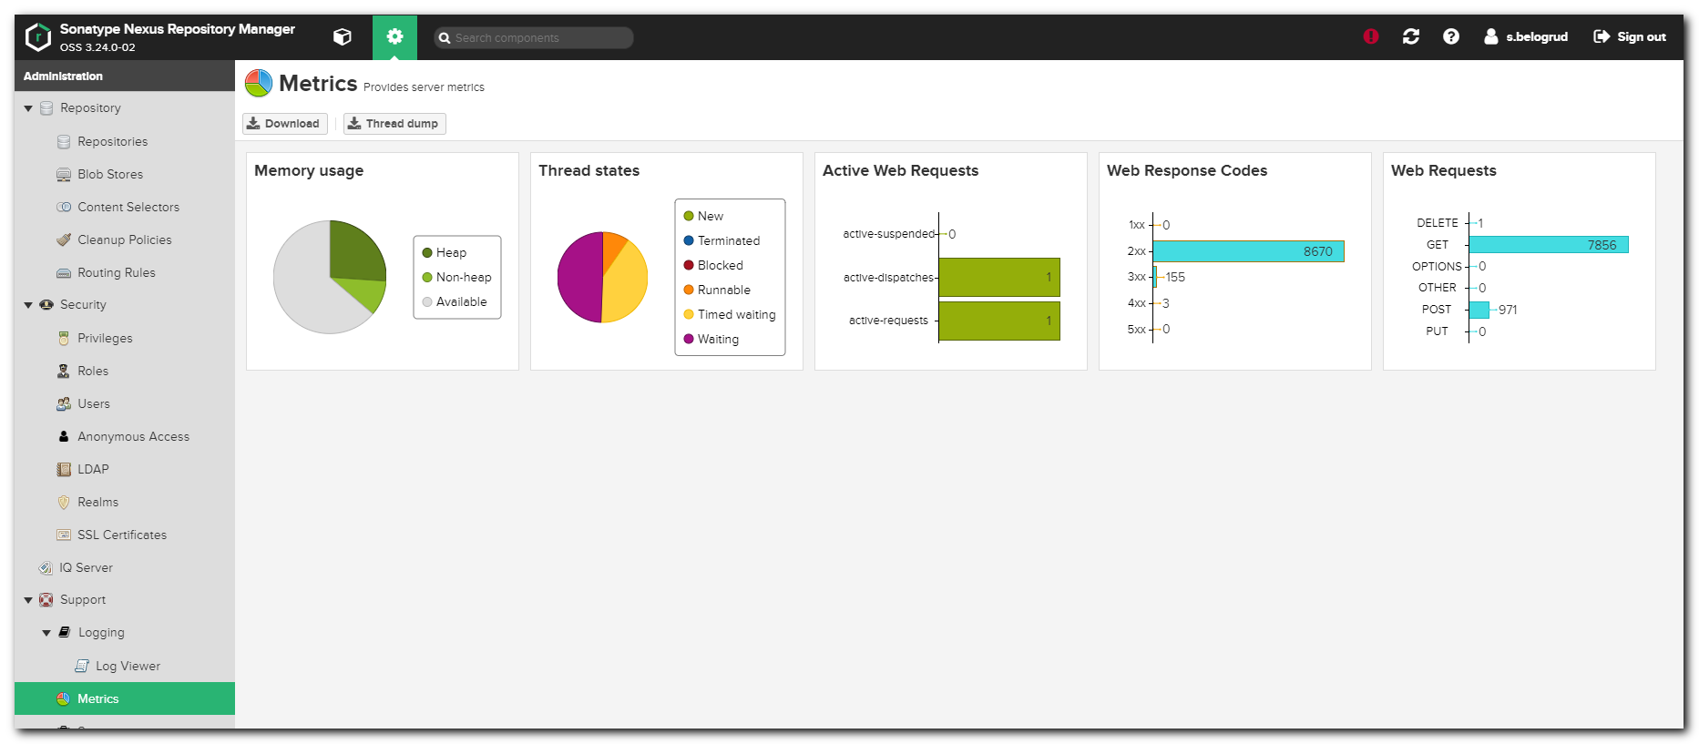

#
# 20200929
#
# Update to OSS 3.27.0-03
#
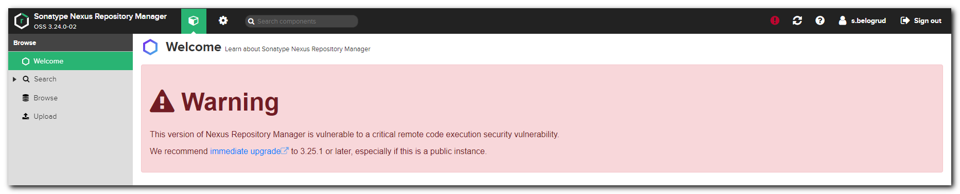
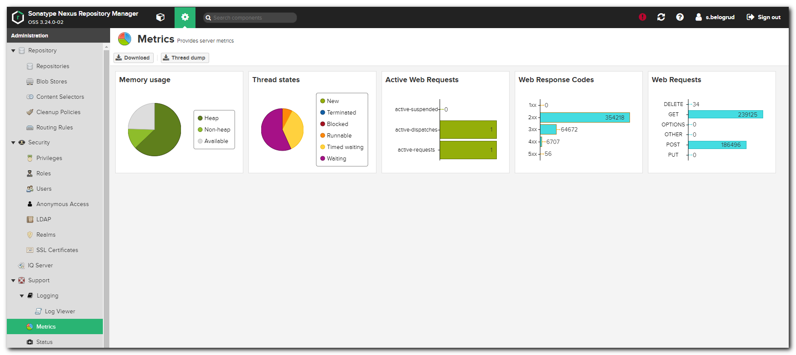

# After update.
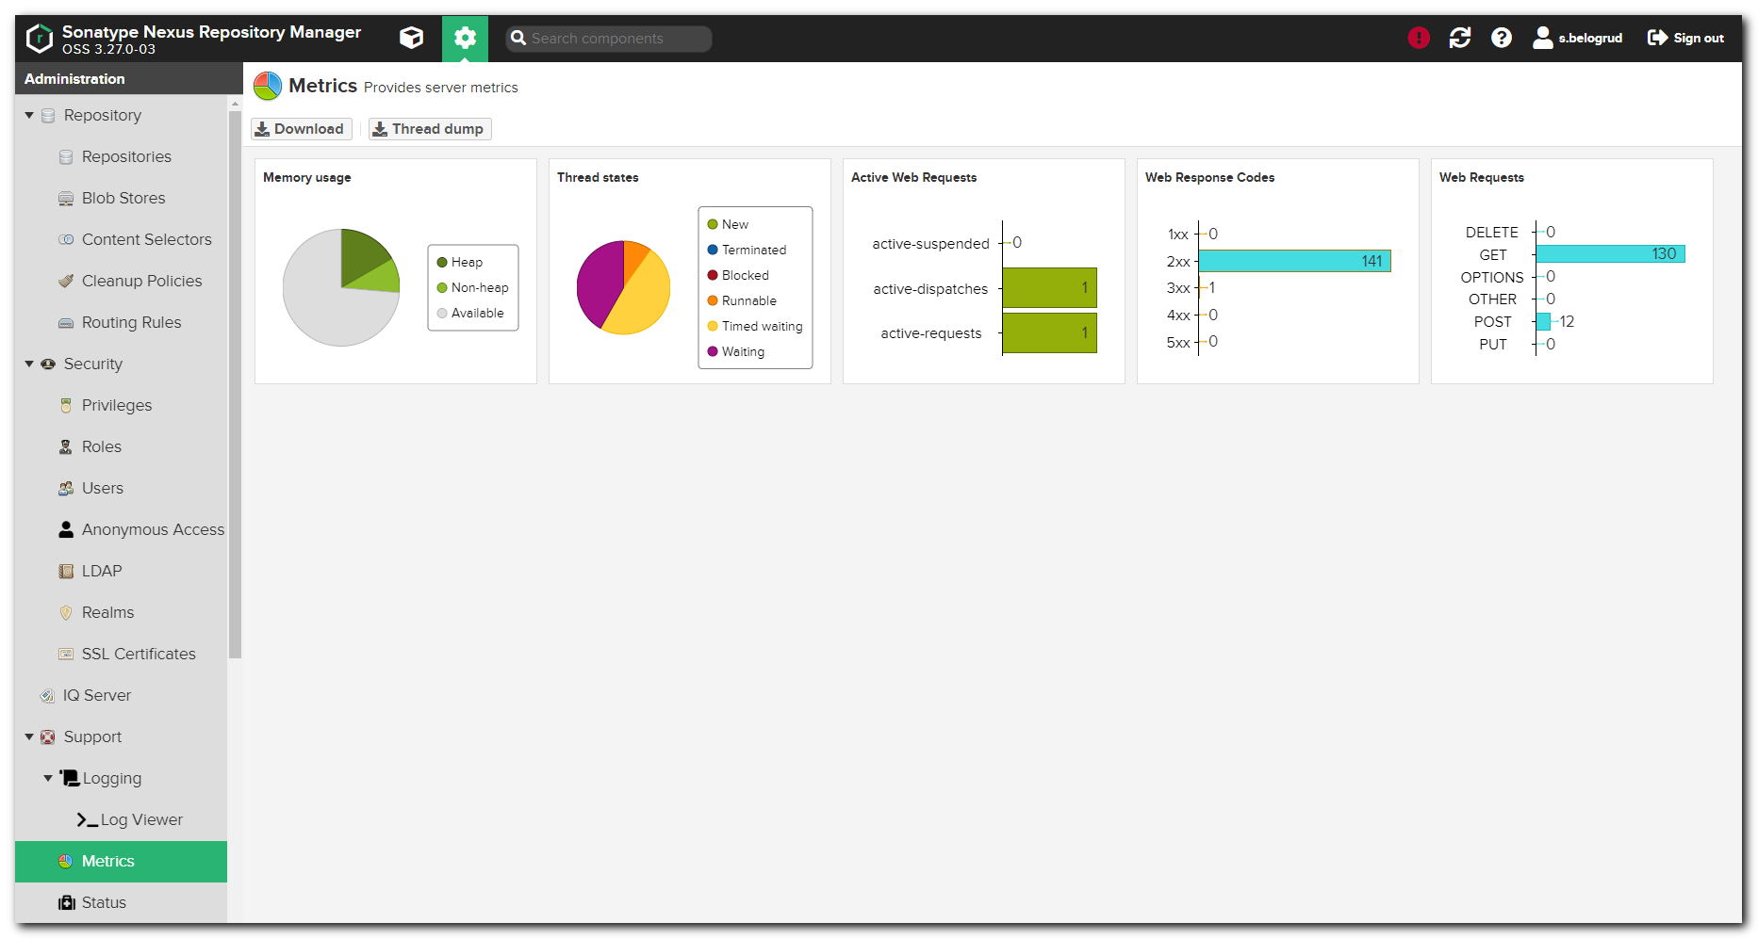

#
# 20210405
# Update from 3.27.0-03 to 3.30.0
#
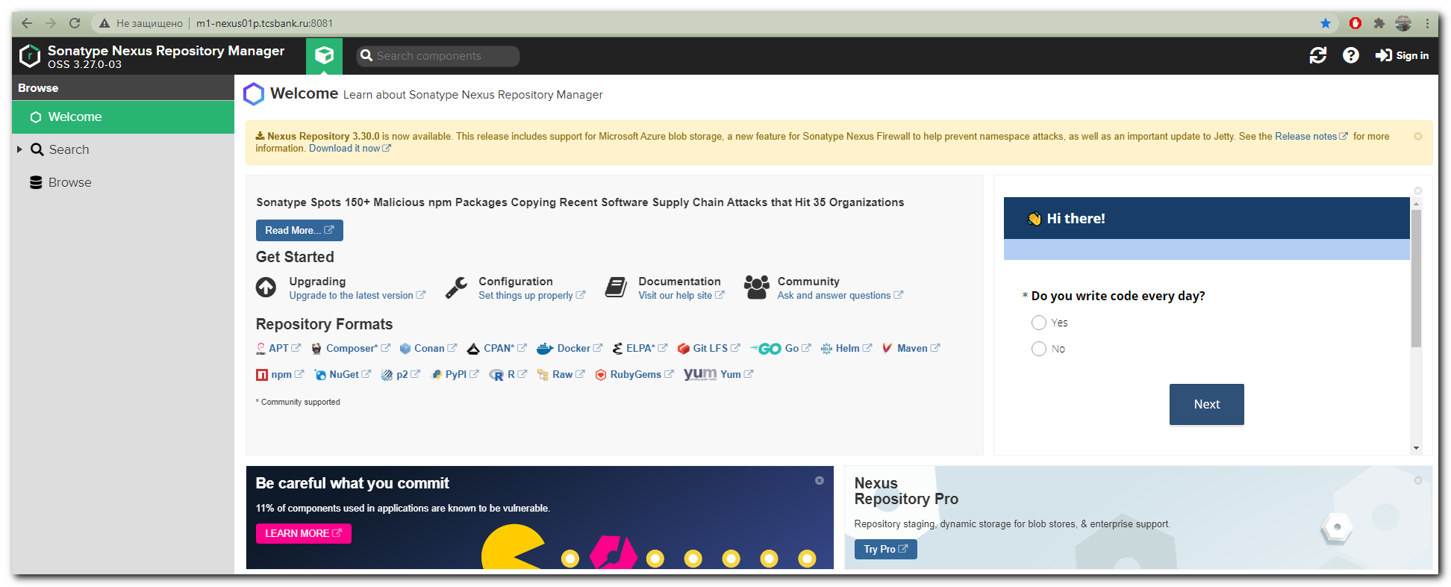
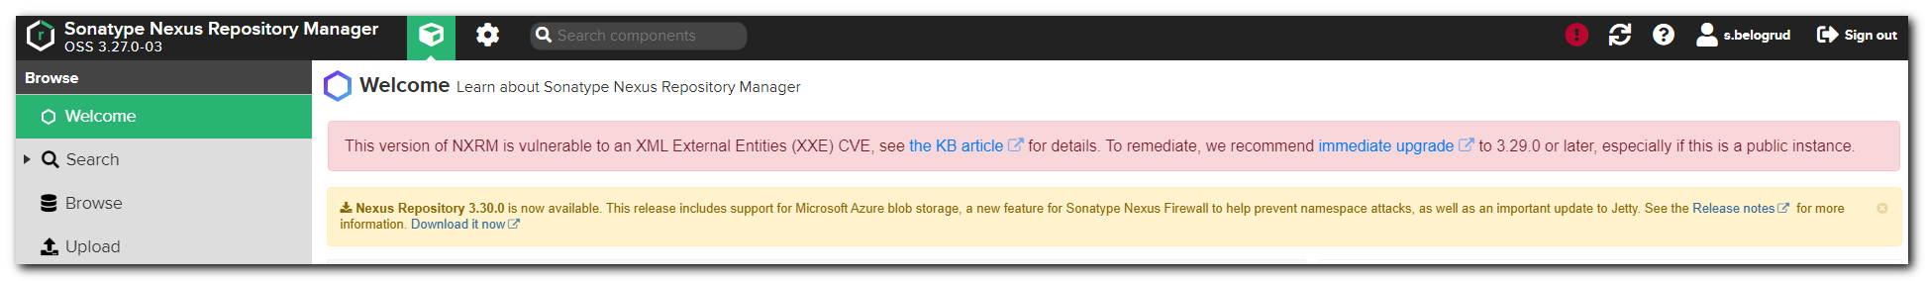
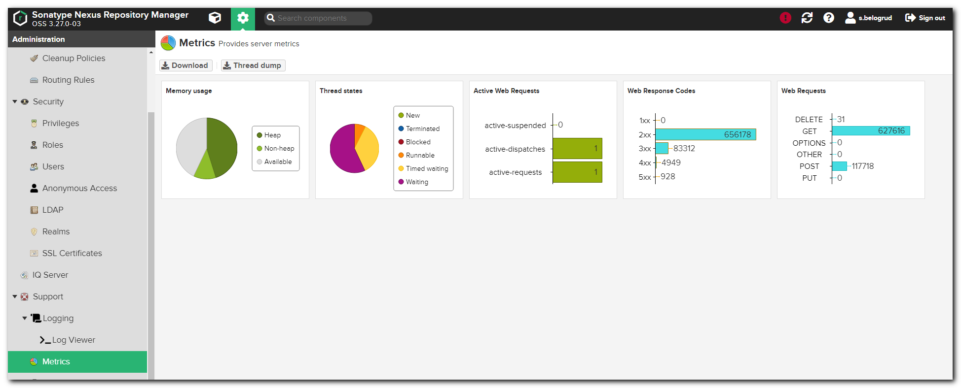

# And after update.
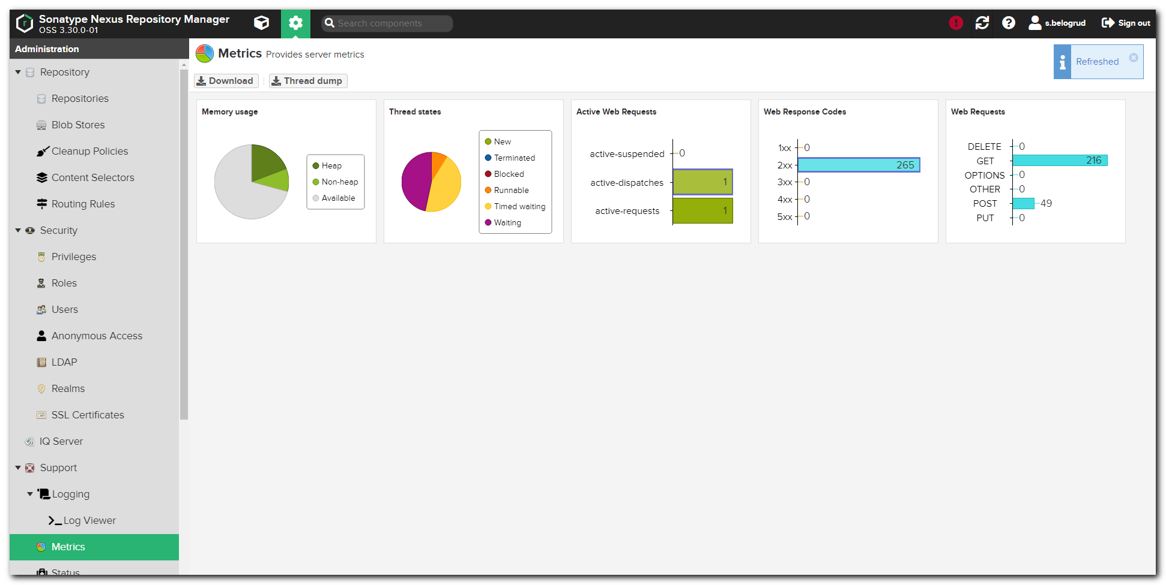

#
# 20210406
# К сожалению попробовать откатиться на предыдущую версию не получилось.
# Я в файлике /etc/systemd/system/nexus.service заменил путь до предыдущей версии.
# Но сервис не запустился - свалился через пару минут запуска.
# Разбираться в ошибке я не стал. Вернуть всё обратно и запустил.
# Посыл был такой, что и некогда и всяко придётся на более новую версию переходить через какое-то время.
#

#
# 20210407
#
# Nikolaev Roman came across with follow difficulties. Breafly, he couldn't install package squid. And this package couldn't download. There was 404 error.
# https://tinkoff.slack.com/archives/C482SKHJP/p1617796073075100

root@centos 20210407-1517]# yum list available squid
Loaded plugins: langpacks
Repodata is over 2 weeks old. Install yum-cron? Or run: yum makecache fast
Available Packages
squid.x86_64 7:3.5.20-17.el7_9.5 patch-centos-7-updates
[root@centos 20210407-1517]# yumdownloader squid
...
squid-3.5.20-17.el7_9.5.x86_64 FAILED
http://repo-linux.tcsbank.ru/repository/centos/centos/7/updates/x86_64/Packages/squid-3.5.20-17.el7_9.5.x86_64.rpm: [Errno 14] HTTP Error 404 - Not Found ] 0.0 B/s | 0 B --:--:-- ETA
Trying other mirror.
To address this issue please refer to the below knowledge base article

https://access.redhat.com/articles/1320623

If above article doesn't help to resolve this issue please create a bug on https://bugs.centos.org/

7:squid-3.5.20-17.el7_9.5.x86_64: [Errno 256] No more mirrors to try.
[root@centos 20210407-1517]#

#
# https://tinkoff.slack.com/archives/CTRAME9LP/p1617801825111000
Похоже в текущей версии nexus OSS 3.30.0-01 есть баг с доступом к raw репозиториям: https://issues.sonatype.org/browse/NEXUS-27013
При запросе nexus всего-то заменяет слеши на %2F и т.п.
Попробую пропатчить nexus. Это значит, что минут на 5 доступ к репозиториям "моргнёт".

[s.belogrud@nb2339]# scp /drives/c/Users/s.belogrud/Downloads/nexus-* bsv@m1-nexus01p:/tmp/
nexus-common-3.30.0-01.jar 100% 189KB 2.4MB/s 00:00
nexus-repository-raw-3.30.0-01.jar 100% 81KB 2.7MB/s 00:00
[s.belogrud@nb2339]#

[root@m1-nexus01p ~]# mkdir -p ~/work/20210407-1635
[root@m1-nexus01p ~]# mkdir -p ~/work/20210407-1635/backup
[root@m1-nexus01p ~]# mkdir -p ~/work/20210407-1635/patches
[root@m1-nexus01p ~]# cd ~/work/20210407-1635/
[root@m1-nexus01p 20210407-1635]# cp /tmp/nexus-* patches/
[root@m1-nexus01p 20210407-1635]# ll patches/
total 276
-rwx------ 1 root root 193821 Apr 7 16:36 nexus-common-3.30.0-01.jar
-rwx------ 1 root root 82440 Apr 7 16:36 nexus-repository-raw-3.30.0-01.jar
[root@m1-nexus01p 20210407-1635]# sha1sum patches/*.jar
525a97f8ca4e0adcd1f70d3491465107394b1305 patches/nexus-common-3.30.0-01.jar
8a32e3946fe1c96842e19ca263d0b85128d9642f patches/nexus-repository-raw-3.30.0-01.jar
[root@m1-nexus01p 20210407-1635]#

[root@m1-nexus01p 20210407-1635]# ls -Alh /opt/nexus/nexus-3.30.0-01/system/org/sonatype/nexus/nexus-common/3.30.0-01/nexus-common-3.30.0-01.jar
-rw-r--r-- 1 root root 189K Mar 3 04:04 /opt/nexus/nexus-3.30.0-01/system/org/sonatype/nexus/nexus-common/3.30.0-01/nexus-common-3.30.0-01.jar
[root@m1-nexus01p 20210407-1635]# ls -Alh /opt/nexus/nexus-3.30.0-01/system/org/sonatype/nexus/plugins/nexus-repository-raw/3.30.0-01/nexus-repository-raw-3.30.0-01.jar
-rw-r--r-- 1 root root 81K Mar 3 04:04 /opt/nexus/nexus-3.30.0-01/system/org/sonatype/nexus/plugins/nexus-repository-raw/3.30.0-01/nexus-repository-raw-3.30.0-01.jar
[root@m1-nexus01p 20210407-1635]#

[root@m1-nexus01p 20210407-1635]# cp /opt/nexus/nexus-3.30.0-01/system/org/sonatype/nexus/nexus-common/3.30.0-01/nexus-common-3.30.0-01.jar backup/
[root@m1-nexus01p 20210407-1635]# cp /opt/nexus/nexus-3.30.0-01/system/org/sonatype/nexus/plugins/nexus-repository-raw/3.30.0-01/nexus-repository-raw-3.30.0-01.jar backup/
[root@m1-nexus01p 20210407-1635]# ls -Alh backup/
total 276K
-rw-r--r-- 1 root root 189K Apr 7 16:41 nexus-common-3.30.0-01.jar
-rw-r--r-- 1 root root 81K Apr 7 16:41 nexus-repository-raw-3.30.0-01.jar
[root@m1-nexus01p 20210407-1635]#

[root@m1-nexus01p 20210407-1635]# systemctl status nexus
● nexus.service - nexus service
Loaded: loaded (/etc/systemd/system/nexus.service; enabled; vendor preset: disabled)
Active: active (running) since Tue 2021-04-06 14:52:56 MSK; 1 day 1h ago
Process: 7826 ExecStart=/opt/nexus/nexus-3.30.0-01/bin/nexus start (code=exited, status=0/SUCCESS)
Main PID: 8007 (java)
CGroup: /system.slice/nexus.service
└─8007 /usr/lib/jvm/java-1.8.0-openjdk-1.8.0.242.b08-0.el7_7.x86_64/jre/bin/java -server -Dinstall4j.jvmDir=/usr/lib/jvm/java-1.8.0-openjdk...

Apr 06 14:52:56 m1-nexus01p.tcsbank.ru systemd[1]: Starting nexus service...
Apr 06 14:52:56 m1-nexus01p.tcsbank.ru systemd[1]: Started nexus service.
[root@m1-nexus01p 20210407-1635]# chmod 644 patches/*.jar
[root@m1-nexus01p 20210407-1635]# ls -Alh patches/
total 276K
-rw-r--r-- 1 root root 190K Apr 7 16:36 nexus-common-3.30.0-01.jar
-rw-r--r-- 1 root root 81K Apr 7 16:36 nexus-repository-raw-3.30.0-01.jar
[root@m1-nexus01p 20210407-1635]#

[root@m1-nexus01p 20210407-1635]# systemctl stop nexus
[root@m1-nexus01p 20210407-1635]# cp patches/nexus-common-3.30.0-01.jar /opt/nexus/nexus-3.30.0-01/system/org/sonatype/nexus/nexus-common/3.30.0-01/nexus-common-3.30.0-01.jar
cp: overwrite ‘/opt/nexus/nexus-3.30.0-01/system/org/sonatype/nexus/nexus-common/3.30.0-01/nexus-common-3.30.0-01.jar’? y
[root@m1-nexus01p 20210407-1635]# cp patches/nexus-repository-raw-3.30.0-01.jar /opt/nexus/nexus-3.30.0-01/system/org/sonatype/nexus/plugins/nexus-repository-raw/3.30.0-01/nexus-repository-raw-3.30.0-01.jar
cp: overwrite ‘/opt/nexus/nexus-3.30.0-01/system/org/sonatype/nexus/plugins/nexus-repository-raw/3.30.0-01/nexus-repository-raw-3.30.0-01.jar’? y
[root@m1-nexus01p 20210407-1635]#
[root@m1-nexus01p 20210407-1635]# systemctl start nexus
[root@m1-nexus01p 20210407-1635]#

#
# For local nexus repository "centos" I returned URL to original repository place:
#
# For temporary fix the bug, I wrote follow URL:
# https://mirror.yandex.ru/
#
# But before troubles was this URL:
# http://mirror.centos.org/
#
#
# Same was with local nexus repository "ubuntu".
#
# Before troubles was this URL: http://us.archive.ubuntu.com/ubuntu/
# To fix troubles I changed it to this URL: https://mirror.yandex.ru/ubuntu/
#

#
# 20210407
# Here is a list of links to Ubuntu mirrors.
http://mirrors.ubuntu.com/mirrors.txt

https://mirror.linux-ia64.org/ubuntu/
http://mirror.timeweb.ru/ubuntu/
http://mirror.yandex.ru/ubuntu/
http://mirror.corbina.net/ubuntu/
https://mirror.truenetwork.ru/ubuntu/
http://mirrors.powernet.com.ru/ubuntu/
http://mirror.logol.ru/ubuntu/
http://mirror.docker.ru/ubuntu/
http://archive.ubuntu.com/ubuntu/

https://launchpad.net/ubuntu/+archivemirrors

